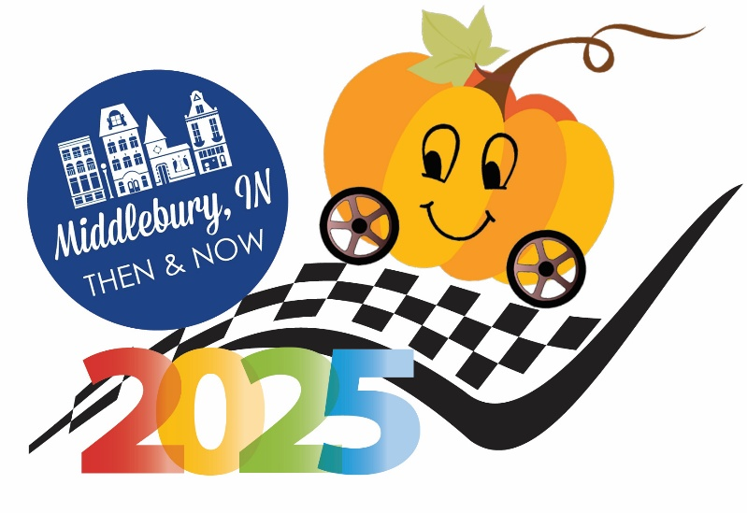
Elkhart County Not for Profits Represented

Boys & Girls Club of Elkhart County
Church Community Services
Elkhart County Health Department
Loveway
Ryan’s Place
United Way

